Machine learning Lab Observation
ITA0614
Experiment 3
Demonstrate the working of the decision tree based ID3 algorithm. Use an appropriate data set for building the decision tree and apply this knowledge to classify a new sample.
Name : HARIHARAN GB
Reg.No : 192412390
Problem 1 : Play Tennis
Aim
To implement the ID3 algorithm in pure Python, build a decision tree for the PlayTennis data set and classify a new sample.
Algorithm
- Create a root node for the training examples S and the list of attributes.
- If all examples in S belong to the same class, return a leaf node labelled with that class.
- If the attribute list is empty, return a leaf node labelled with the most common class in S.
- Otherwise, calculate Entropy(S) = - sum( pi * log2(pi) ) and the Information Gain Gain(S, A) = Entropy(S) - sum( |Sv| / |S| * Entropy(Sv) ) for every attribute A.
- Select the attribute with the highest information gain as the decision node.
- For each value of the selected attribute create a branch and the subset Sv of examples having that value; repeat the procedure recursively on each subset with the remaining attributes.
- To classify a new sample, start at the root and follow the branch matching the sample’s attribute value at every node until a leaf is reached; the leaf label is the predicted class.
Program:
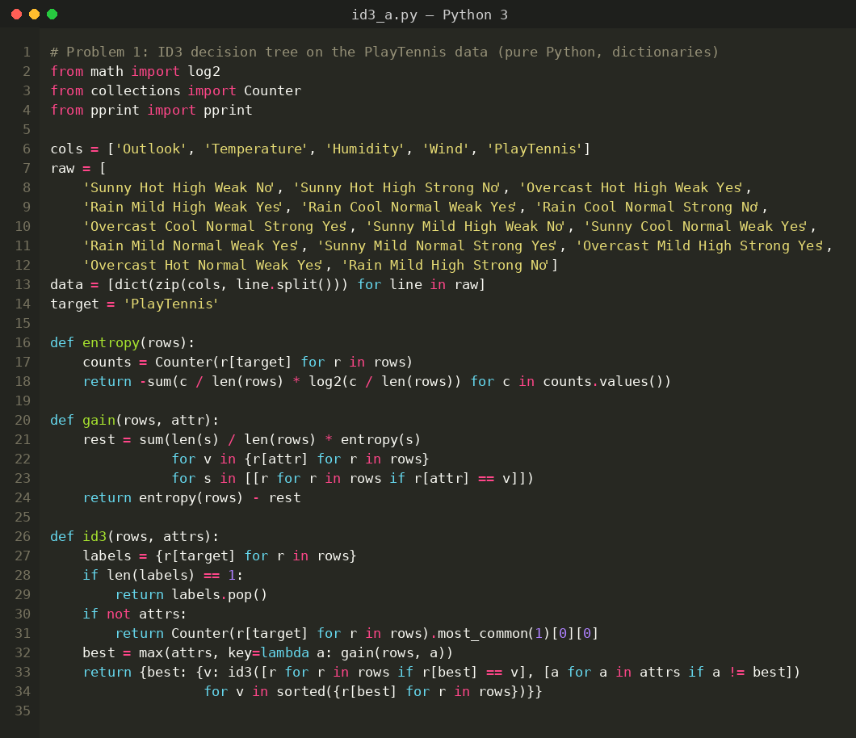
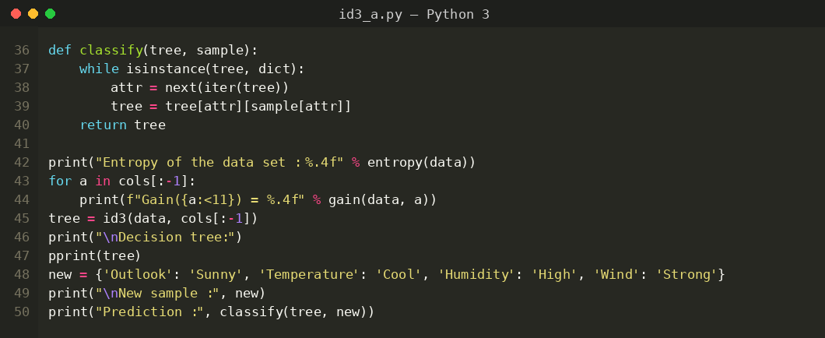
Input
PlayTennis data set: 14 training examples, 4 attributes (Outlook, Temperature, Humidity, Wind) and the class PlayTennis (Yes / No). The new sample to be classified is (Sunny, Cool, High, Strong).
Outlook | Temperature | Humidity | Wind | PlayTennis
Sunny | Hot | High | Weak | No
Sunny | Hot | High | Strong | No
Overcast | Hot | High | Weak | Yes
Rain | Mild | High | Weak | Yes
Rain | Cool | Normal | Weak | Yes
Rain | Cool | Normal | Strong | No
Overcast | Cool | Normal | Strong | Yes
Sunny | Mild | High | Weak | No
Sunny | Cool | Normal | Weak | Yes
Rain | Mild | Normal | Weak | Yes
Sunny | Mild | Normal | Strong | Yes
Overcast | Mild | High | Strong | Yes
Overcast | Hot | Normal | Weak | Yes
Rain | Mild | High | Strong | No
Output
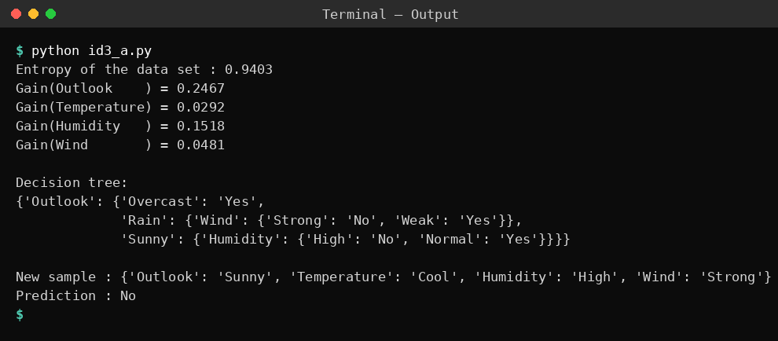
Result
The ID3 algorithm built the decision tree successfully. Outlook has the highest information gain (0.2467) and becomes the root: Overcast gives Yes, Sunny is split on Humidity (High = No, Normal = Yes) and Rain is split on Wind (Strong = No, Weak = Yes). The new sample (Sunny, Cool, High, Strong) is classified as PlayTennis = No.
Problem 2: Customer Churn
Aim
To build an ID3 decision tree for customer churn data using pandas and NumPy, display the tree in indented form and classify a new customer.
Algorithm
- Create a root node for the training examples S and the list of attributes.
- If all examples in S belong to the same class, return a leaf node labelled with that class.
- If the attribute list is empty, return a leaf node labelled with the most common class in S.
- Otherwise, calculate Entropy(S) = - sum( pi * log2(pi) ) and the Information Gain Gain(S, A) = Entropy(S) - sum( |Sv| / |S| * Entropy(Sv) ) for every attribute A.
- Select the attribute with the highest information gain as the decision node.
- For each value of the selected attribute create a branch and the subset Sv of examples having that value; repeat the procedure recursively on each subset with the remaining attributes.
- To classify a new sample, start at the root and follow the branch matching the sample’s attribute value at every node until a leaf is reached; the leaf label is the predicted class.
Program:
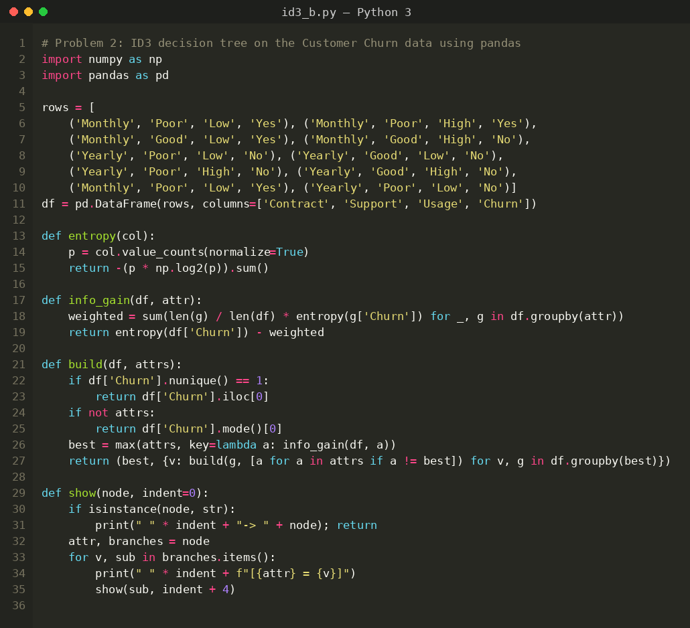
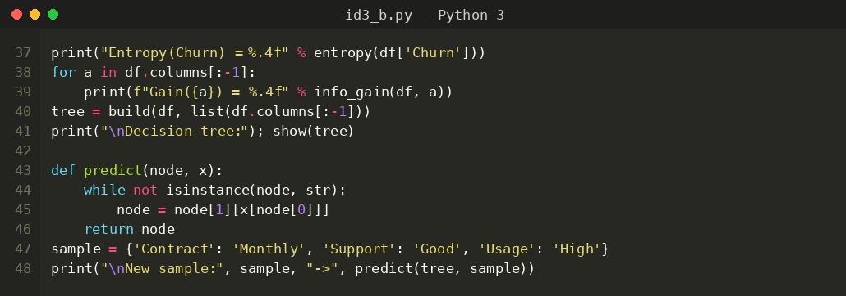
Input
Customer Churn data set: 10 training examples, 3 attributes (Contract, Support, Usage) and the class Churn (Yes / No). The new sample to be classified is (Monthly, Good, High).
Contract | Support | Usage | Churn
Monthly | Poor | Low | Yes
Monthly | Poor | High | Yes
Monthly | Good | Low | Yes
Monthly | Good | High | No
Yearly | Poor | Low | No
Yearly | Good | Low | No
Yearly | Poor | High | No
Yearly | Good | High | No
Monthly | Poor | Low | Yes
Yearly | Poor | Low | No
Output
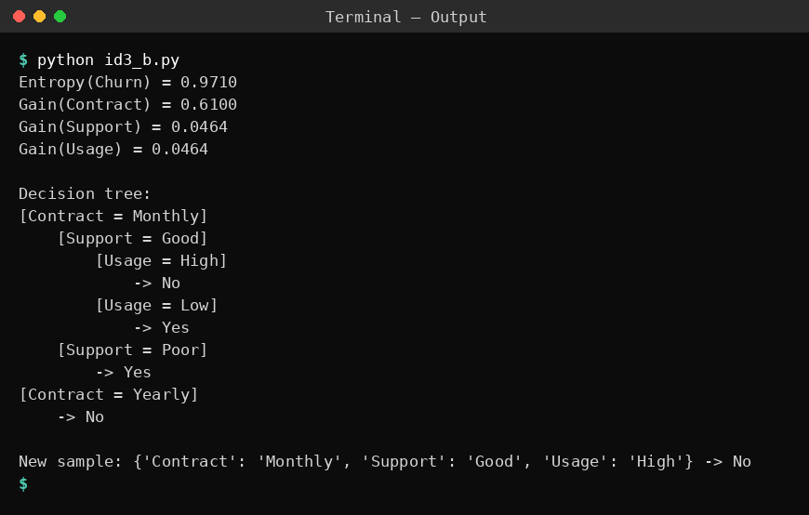
Result
Contract has the highest information gain (0.6100) and is chosen as the root. Yearly contracts always give No; for Monthly contracts, Poor support gives Yes, while Good support is split on Usage (Low = Yes, High = No). The new customer (Monthly, Good, High) is classified as Churn = No.
Problem 3: Loan Approval
Aim
To build an ID3 decision tree for loan approval data read from a .CSV file and use it to classify a new applicant.
Algorithm
- Create a root node for the training examples S and the list of attributes.
- If all examples in S belong to the same class, return a leaf node labelled with that class.
- If the attribute list is empty, return a leaf node labelled with the most common class in S.
- Otherwise, calculate Entropy(S) = - sum( pi * log2(pi) ) and the Information Gain Gain(S, A) = Entropy(S) - sum( |Sv| / |S| * Entropy(Sv) ) for every attribute A.
- Select the attribute with the highest information gain as the decision node.
- For each value of the selected attribute create a branch and the subset Sv of examples having that value; repeat the procedure recursively on each subset with the remaining attributes.
- To classify a new sample, start at the root and follow the branch matching the sample’s attribute value at every node until a leaf is reached; the leaf label is the predicted class.
Program:
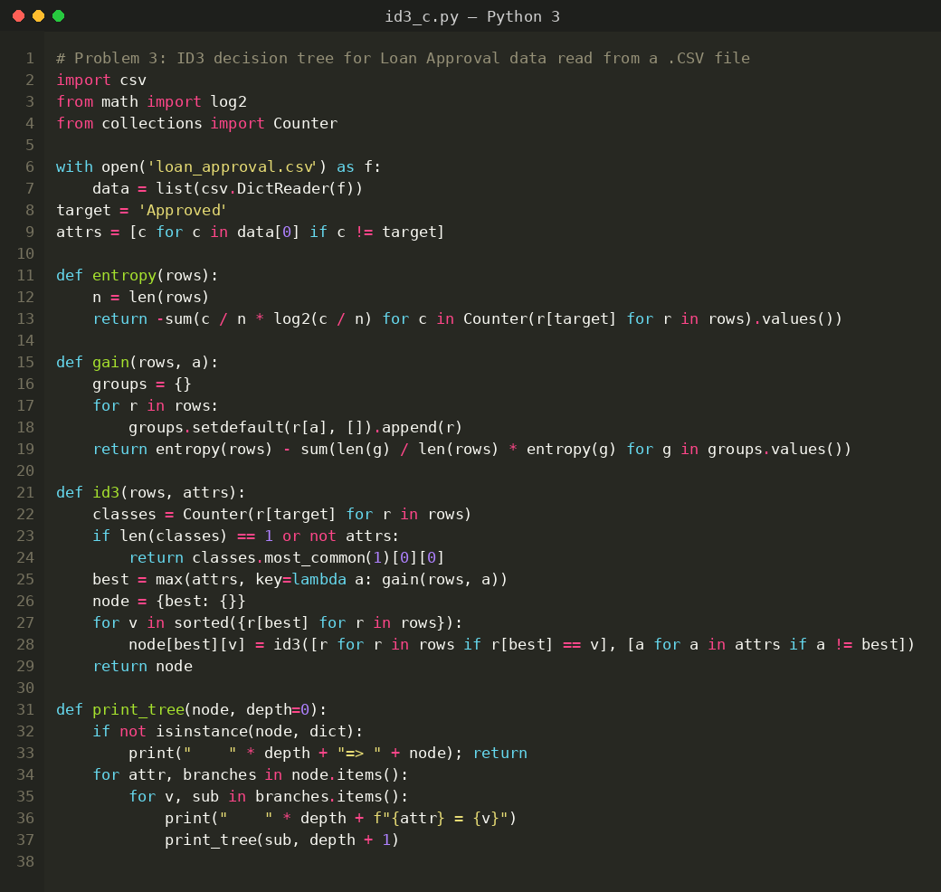
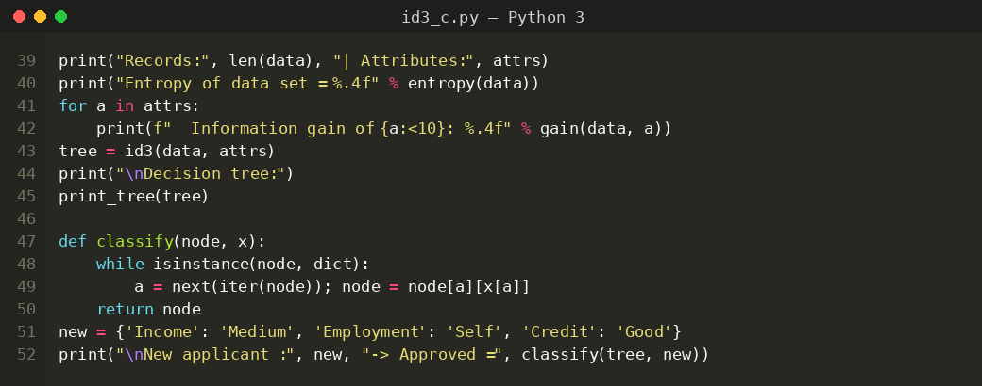
Input
Loan Approval data set (loan_approval.csv): 10 training examples, 3 attributes (Income, Employment, Credit) and the class Approved (Yes / No). The new applicant to be classified is (Medium, Self, Good).
Income | Employment | Credit | Approved
High | Salaried | Good | Yes
High | Salaried | Bad | No
High | Self | Good | Yes
Medium | Salaried | Good | Yes
Medium | Self | Bad | No
Medium | Self | Good | Yes
Low | Salaried | Bad | No
Low | Self | Bad | No
Low | Salaried | Good | No
Low | Self | Good | No
Output
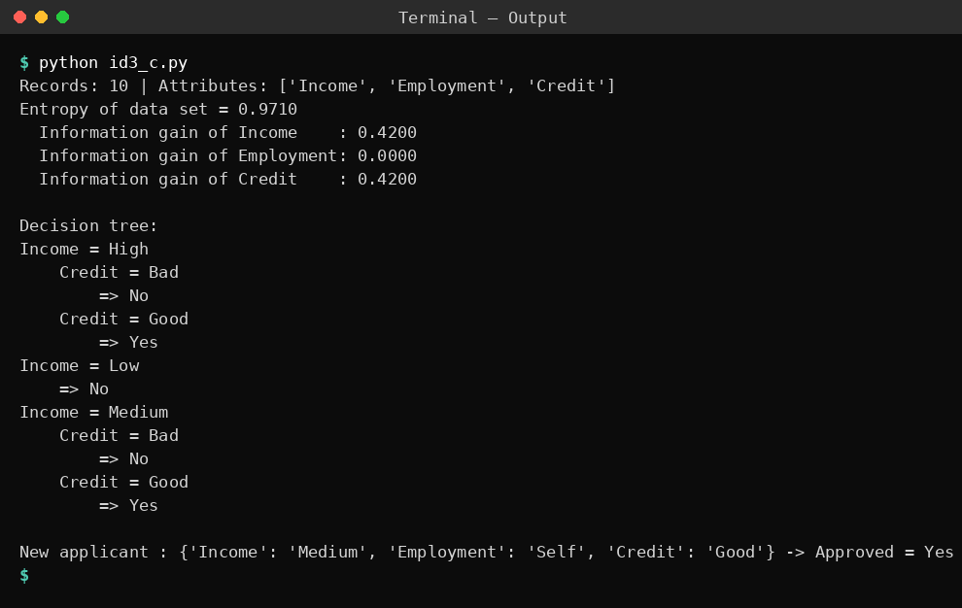
Result
Income and Credit have the same highest information gain (0.4200) and Income is selected first; Employment has zero gain and is not used. For High and Medium income the loan is approved only when Credit is Good, and Low income is always rejected. The new applicant (Medium, Self, Good) is classified as Approved = Yes.
Problem 4: Mushroom Edibility
Aim
To implement the ID3 algorithm as a Python class and use the learned tree to classify new mushroom samples.
Algorithm
- Create a root node for the training examples S and the list of attributes.
- If all examples in S belong to the same class, return a leaf node labelled with that class.
- If the attribute list is empty, return a leaf node labelled with the most common class in S.
- Otherwise, calculate Entropy(S) = - sum( pi * log2(pi) ) and the Information Gain Gain(S, A) = Entropy(S) - sum( |Sv| / |S| * Entropy(Sv) ) for every attribute A.
- Select the attribute with the highest information gain as the decision node.
- For each value of the selected attribute create a branch and the subset Sv of examples having that value; repeat the procedure recursively on each subset with the remaining attributes.
- To classify a new sample, start at the root and follow the branch matching the sample’s attribute value at every node until a leaf is reached; the leaf label is the predicted class.
Program:
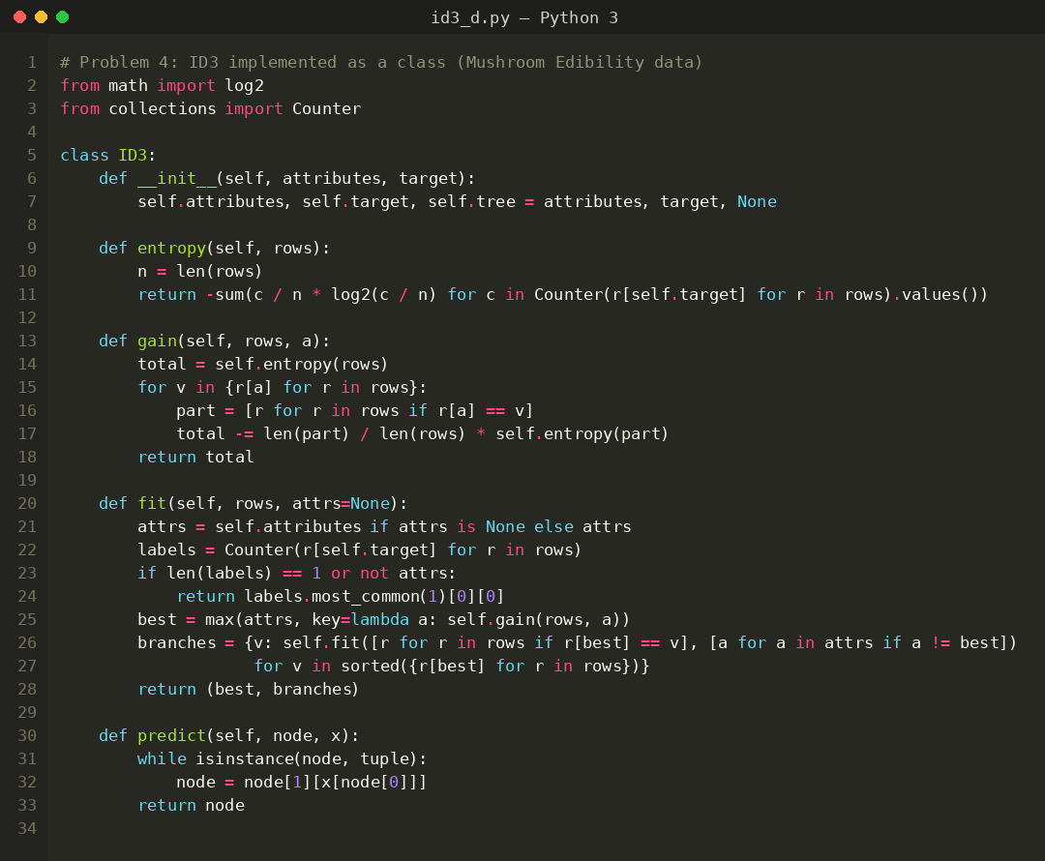
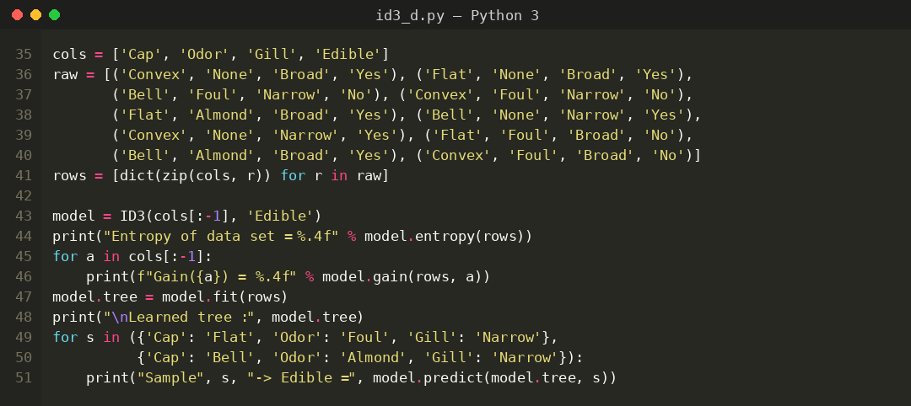
Input
Mushroom data set: 10 training examples, 3 attributes (Cap, Odor, Gill) and the class Edible (Yes / No). The new samples to be classified are (Flat, Foul, Narrow) and (Bell, Almond, Narrow).
Cap | Odor | Gill | Edible
Convex | None | Broad | Yes
Flat | None | Broad | Yes
Bell | Foul | Narrow | No
Convex | Foul | Narrow | No
Flat | Almond | Broad | Yes
Bell | None | Narrow | Yes
Convex | None | Narrow | Yes
Flat | Foul | Broad | No
Bell | Almond | Broad | Yes
Convex | Foul | Broad | No
Output
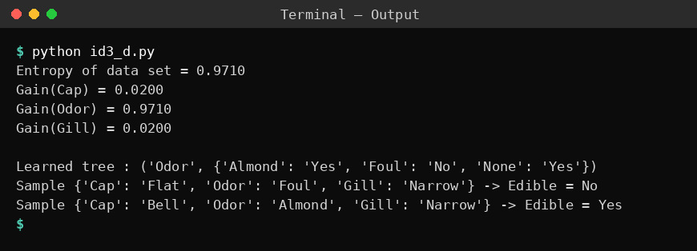
Result
Odor has the highest information gain (0.9710) and it alone separates the classes: Foul gives No, while Almond and None give Yes. Using this tree, (Flat, Foul, Narrow) is classified as Edible = No and (Bell, Almond, Narrow) as Edible = Yes.
Problem 5: Spam Email
Aim
To build an ID3 decision tree for spam email data while displaying the entropy and information gain at every node, and classify new emails.
Algorithm
- Create a root node for the training examples S and the list of attributes.
- If all examples in S belong to the same class, return a leaf node labelled with that class.
- If the attribute list is empty, return a leaf node labelled with the most common class in S.
- Otherwise, calculate Entropy(S) = - sum( pi * log2(pi) ) and the Information Gain Gain(S, A) = Entropy(S) - sum( |Sv| / |S| * Entropy(Sv) ) for every attribute A.
- Select the attribute with the highest information gain as the decision node.
- For each value of the selected attribute create a branch and the subset Sv of examples having that value; repeat the procedure recursively on each subset with the remaining attributes.
- To classify a new sample, start at the root and follow the branch matching the sample’s attribute value at every node until a leaf is reached; the leaf label is the predicted class.
Program:
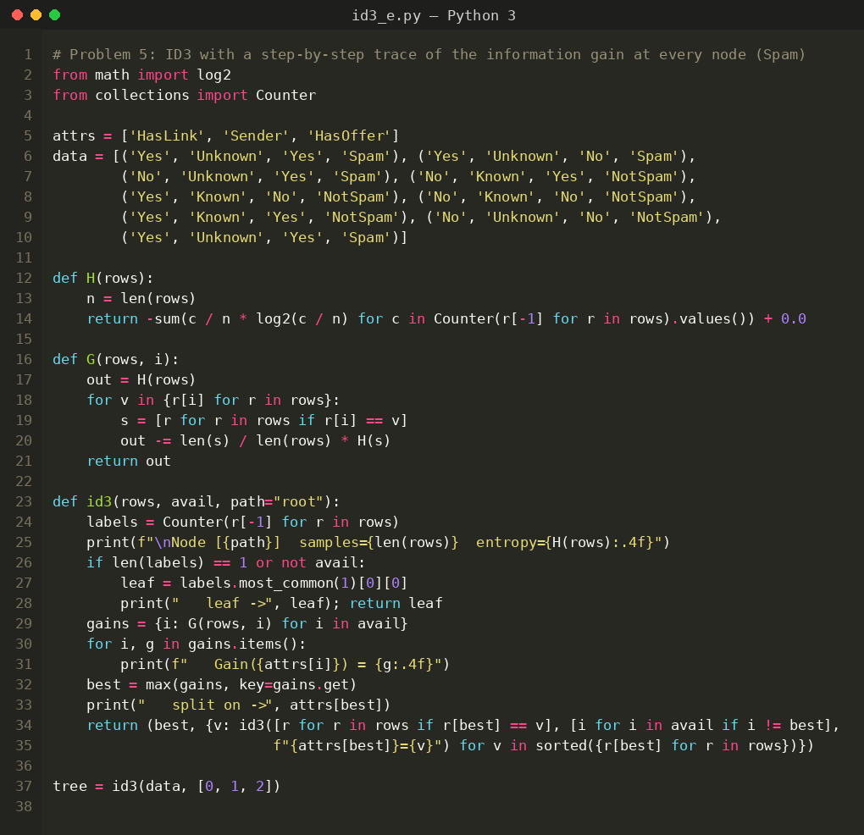
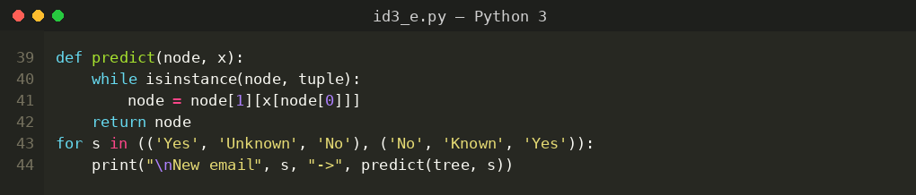
Input
Spam Email data set: 9 training examples, 3 attributes (HasLink, Sender, HasOffer) and the class (Spam / NotSpam). The new emails to be classified are (Yes, Unknown, No) and (No, Known, Yes).
HasLink | Sender | HasOffer | Class
Yes | Unknown | Yes | Spam
Yes | Unknown | No | Spam
No | Unknown | Yes | Spam
No | Known | Yes | NotSpam
Yes | Known | No | NotSpam
No | Known | No | NotSpam
Yes | Known | Yes | NotSpam
No | Unknown | No | NotSpam
Yes | Unknown | Yes | Spam
Output
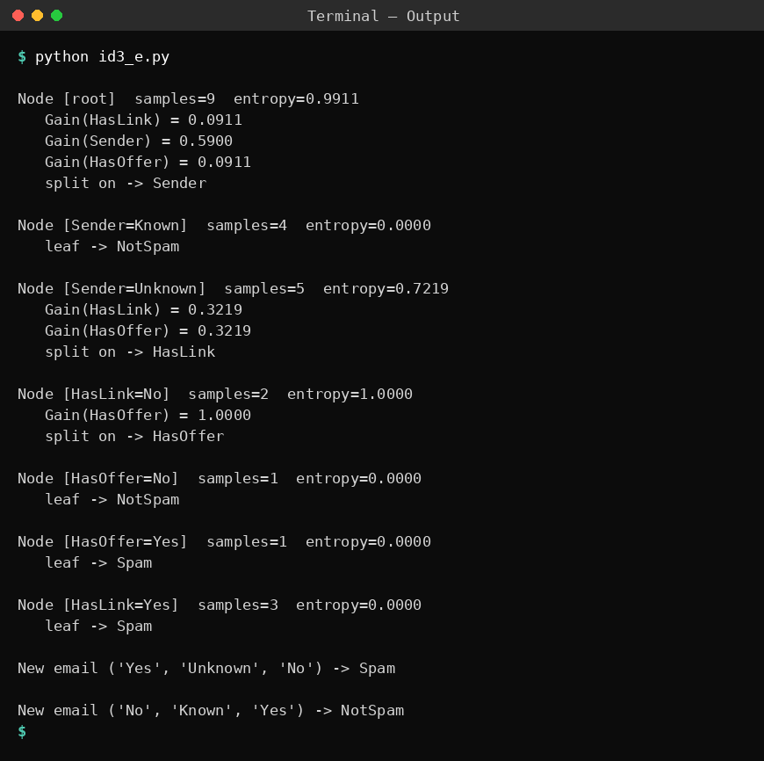
Result
Sender has the highest information gain at the root (0.5900): emails from a Known sender are NotSpam. For Unknown senders the tree splits on HasLink (Yes = Spam); when there is no link it splits on HasOffer (Yes = Spam, No = NotSpam). The new email (Yes, Unknown, No) is classified as Spam and (No, Known, Yes) as NotSpam.

